Room Assignments:
General Sessions/Plenaries | Frost/Hawthorn | Mezzanine (2nd Floor)
Breakouts: Program Management | Dartmouth | Mezzanine (2nd Floor)
Breakouts: Victim-Centered Restorative Justice | Frost/Hawthorn | Mezzanine (2nd Floor)
Exhibitors | Hallway | Mezzanine (2nd Floor)
Reception | Penstock | Lobby Level
Breakfast/Lunch | Penstock | Lobby Level
Board Meeting (Friday) | Coolidge | Mezzanine (2nd Floor)

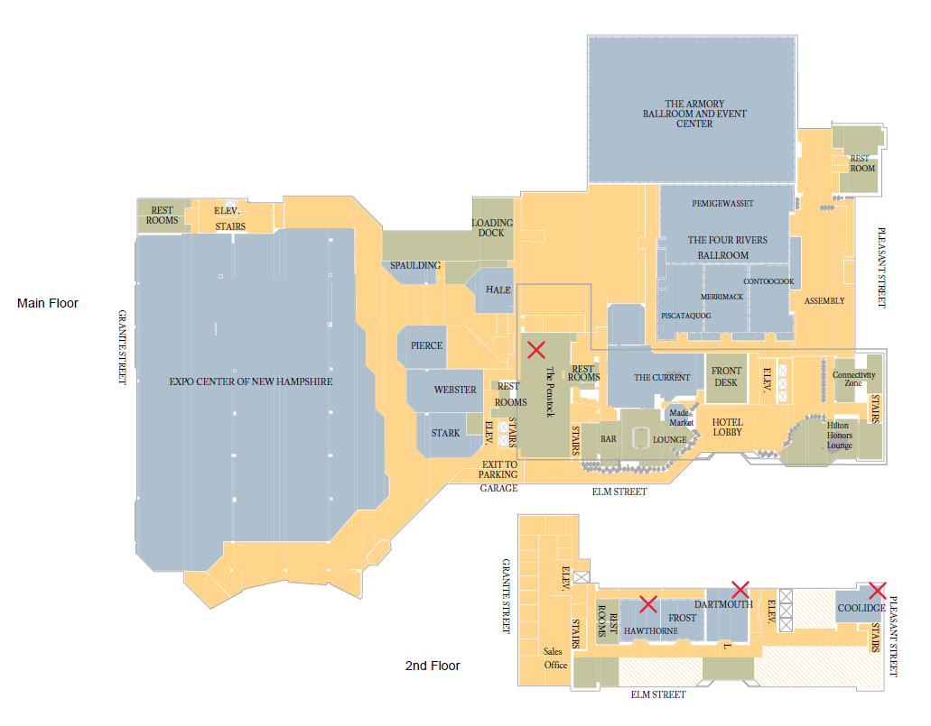

MONDAY, September 12
4:00 pm – 5:30 | Registration Open
4:00 –8:00 | Exhibit Area Open
4:00 – 5:00 | Special Pre-Conference Session:  Welcoming In: Building Resilient Teams  Lisa Tieszen and Katherine Manners
5:30 – 8:00 | Welcome Reception

TUESDAY, September 13
7:00 am Breakfast Opens / 7:30 am Registration/Information/Exhibit Area Opens
8:30 – 10:30 | Welcome Ceremony:  New Hampshire Department of Corrections Assistant Commissioner Paul D Raymond, Jr.  New Hampshire Department of Corrections Honor Guard  National Anthem performed by NH DOC Correctional Officer Forbes  Keynote Speakers:  Scarlett Lewis with Shannon Desilets - Choose Love Movement
11 – 11:45 | Breakouts:
 | Investigations and PREA  Jean Carroll and Heidi Laramie and James Azzara | The Process of Healing for Victims and Survivors  Mary Zinkin
12 – 12:45 | The Voices Inside: How Volunteering Inside a Max-security Prison Helped Me Forgive the Man Who Murdered My Brother  Liberty Miller
Lunch Provided / Exhibitor Area Open
1:45 – 2:30 | Breakouts:
 | Ensuring Victims' Rights in the Post-Conviction, Appeal and GEI process  Stephanie Stocks and Kamaile Luke | "Yeah, I'm All Set"  Nicole Kipphut, Kerri Spence, and Jester  ** This workshop: 1:45 – 3:30
3 – 3:45 | Breakouts:
NIC National Update
Lorie Brisbin
4 – 5 | Accountability Letters: The Good, the Bad, & the Ugly  Nicole Kipphut

Wednesday, September 14
7:00 am Breakfast Served / 7:30 am Registration/Information/Exhibit Area Opens
8:30 – 9:30 | Guest Speakers:  The Role of a Police Comfort Dog, featuring K9s Liberty and Patch
10 – 11:15 | Breakouts:
 | Victim Restitution Matters: Four Lessons from Hawai'i to Ensure Financial Justice for Crime Victims  Pamela Ferguson-Brey and Amanda Sawa | The Mend Collaborative VOD Model: A survivor-centered restorative model of VOD facilitation  Rebecca Weiker, Miguel Quezada and Kim Jordan
11:45 – 12:45 | Breakouts:
 | Supporting Crime Victims in Post-Conviction Exonerations  Natalia Aguirre | VOD Case Examples - Learning from our Challenges, Celebrating Courage  Mary Zinkin and Mary Roche
Lunch Provided / Exhibitor Area Open
1:45 – 3:15 | Breakouts:
 | Assistance for Crime Victims - New Hampshire's CVC Program  Lisa Lamphere | Facilitating Rigorously Victim-Centered VOD Preparation with Offenders in a Growing World of Offender-Focused Prison Restorative Justice Initiatives  Jon Wilson
3:45 – 5 | NAVAC Presentation with NIC and Business Mtg – Members only need attend  Saydyie Derosia with Lorie Brisbin

Thursday Morning, September 15
7:00 am Breakfast Served / 7:30 am Registration/Information/Exhibit Area Opens
8:30 – 9:45 | An In-depth Look at Ohio's Victim Offender Dialogue Program; Facilitator Selection, Training, Retention and Program Management  Crystal Alexander and Jennifer Conkle
10:15 – 11:05 | Keynote:  Flight Fright Freeze Laugh:  Using Humor to Combat Vicarious Traumatization, Handle Stress… and Have Fun!  Kelli Dunham
11:30 – 12:30 | Breakouts:
 | NAAVI, Enhancing Victim Experiences through Technology  Amber Leake and Emily Sattie | Empowering Victims and Maximizing Their Healing Through Active Engagement in the Rehabilitation of the Incarcerated  Martina Lutz Schneider, Elle Dowdy, Deidre Wilson, Jane Piper, and Pete B. Maspaitella
Lunch Provided / Exhibitor Area Open
Thursday afternoon, September 15
1:30 – 2:45 | Breakouts:
 | Line of Duty Death: What We Learned After the Murders at the Iowa Anamosa Penitentiary  Mary Roche | Got Five Minutes: You've Got Self-Care  Kelli Dunham
3 – 4 | Breakouts:
 | Georgia's Unique Approach to Serving Crime Victims Post Conviction  Rita Rocker, Keir Chapple and Christopher Toussant | Evolving Victim's Needs in Texas VOMD Program  Mark Odom
4:15 – 5 | Self-Care with a Chair and Other Vicarious Trauma Strategies  Jacquie “Sunny” Barbee

Friday, September 16
7:00 am Breakfast Served / 7:30 am Registration/Information Opens
8:30 – 9:45 | Planning for Excellence  Jeralita Costa
10 – 11 | Breakouts:
 | TRAUMA: Through the Lens of Correctional Staff Providing Victim Services to Our Employees  Karin Ho with Flossy | Volunteers in VOD  Mike Young
11:15 – 12:15 | Breakouts:
 | Post-Conviction Assistance for Victims (PAV) Hawai'i: Pavhawaii.com, An Innovative Solution to Post-Conviction Advocacy  Randi Barreto and Leanna Bair | Collaboration - Working Together for a Successful VOD  Amanda Rohrbaugh and Traci Lederer
12:30 – 1:30 | NAVAC Presentation and Closing
 | Lunch on your own
2 – 5 | NAVAC Board Meeting – All are invited

