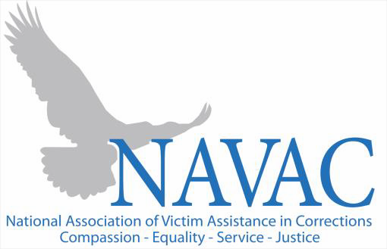
Lisa Kinard Jeralita Costa Chairperson Treasurer
Florida DOC Washington DOC

Traci Lederer Jaquel Moody
Vice Chairperson Secretary
New Hampshire DOC Arizona DOC

Tessa Mosher Chrissy Ruuska
At-Large Member At-Large Member
Maine DOC Massachusetts DOC

2023 NAVAC MEMBERSHIP APPLICATION
Supplemental Form for Organizations or Programs with 3, 6 or 10 Memberships

Your Name:
Your Agency:
Your Email:
Select the membership category that you indicated on your online application.
Remember to return to the NAVAC website for payment options.

Adult and Juvenile Governmental Post-Conviction Victim Service Organization (up to 10 employees): $500
Adult and Juvenile Governmental Post-Conviction Victim Service Program (up to 6 employees): $300
Adult and Juvenile Governmental Post-Conviction Victim Service Program (up to 3 employees): $150
Individuals – Governmental Employees / Retiree non-affiliated: $75
Individuals – Non-Governmental Employee: $100
Allied Professional Associations/Organization (up to 3 staff): $200
Students – of Universities and Colleges: $50

Organizational or Program ONLY
(Up to 3, 6 or 10 staff members as appropriate based on membership category selected above)
Member Name | Title | Phone | Email

THIS FORM IS FOR AN ORGANIZATION OR PROGRAM SELECTING A MEMBERSHIP WITH MORE THAN ONE STAFF MEMBER.

